**怎么在HPC上运行从charmm-gui上下载的文件的教程！！**

**阅读前注意：本教程中[]里面的内容均为command，您可以直接复制[]里的内容去运行指令。**

**1.Preperation**

Assume you have the zip folder downloaded from charm-gui, like this:



Just for suggestion: For successfully find your folder on HPC, change your file name without space, brackets…

For example, I change the folder name into:



**charmm-gui-(target)-(side length)**

Then unzip it, and open it find the file “gromacs”

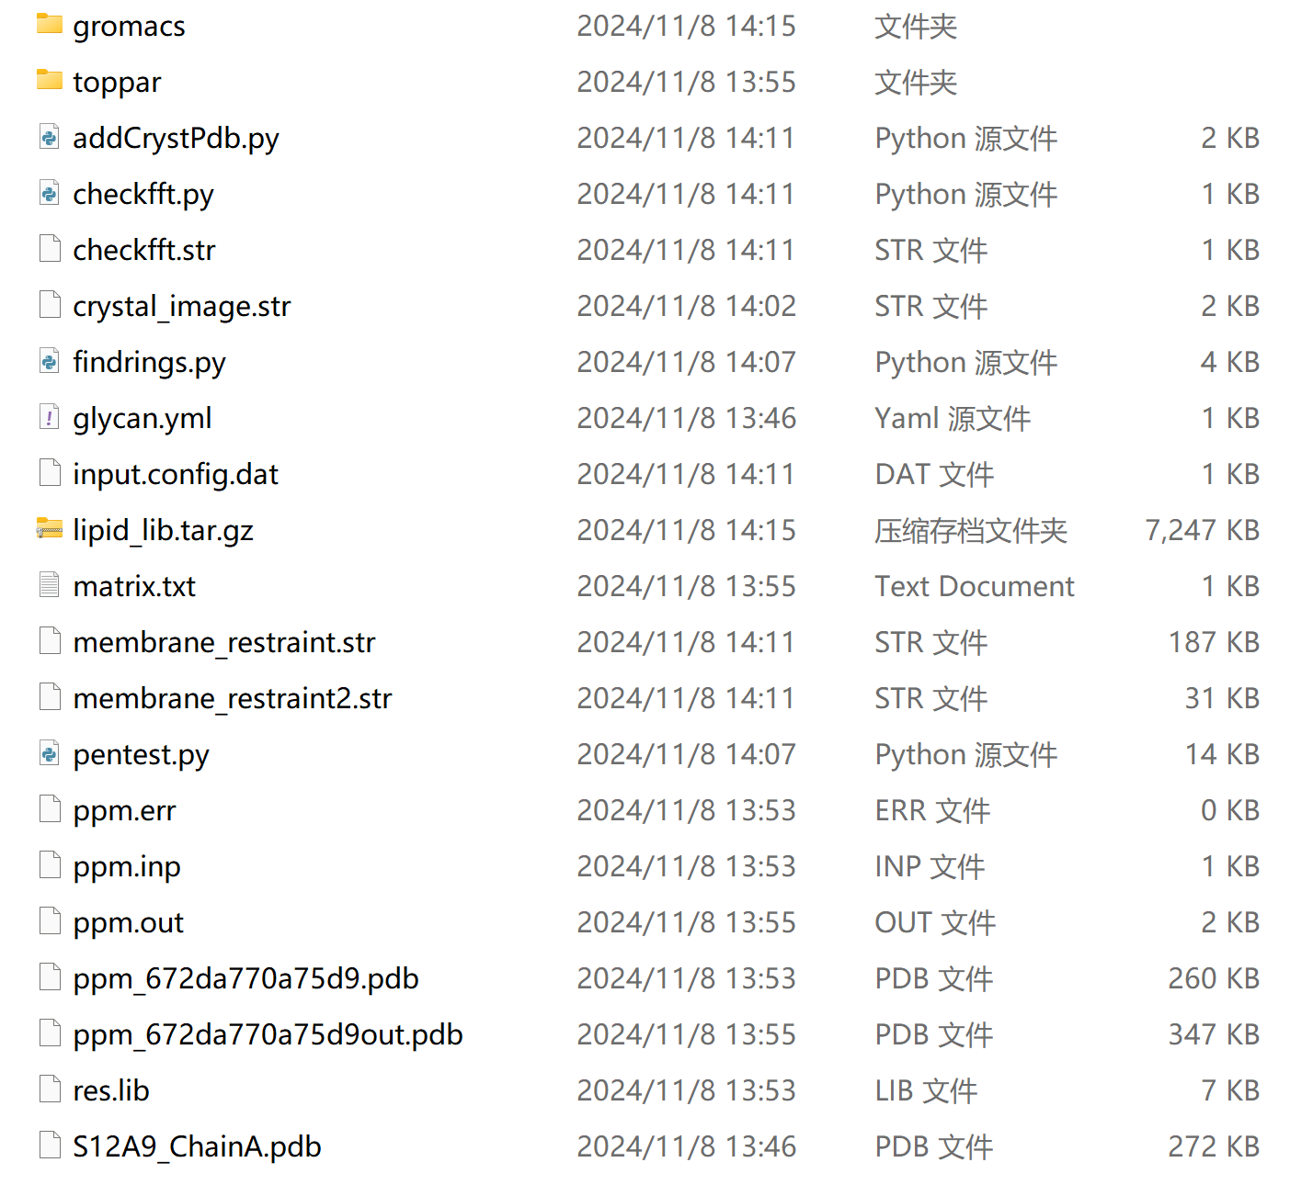

Open it, and you can find all the file you need to use for MD :)

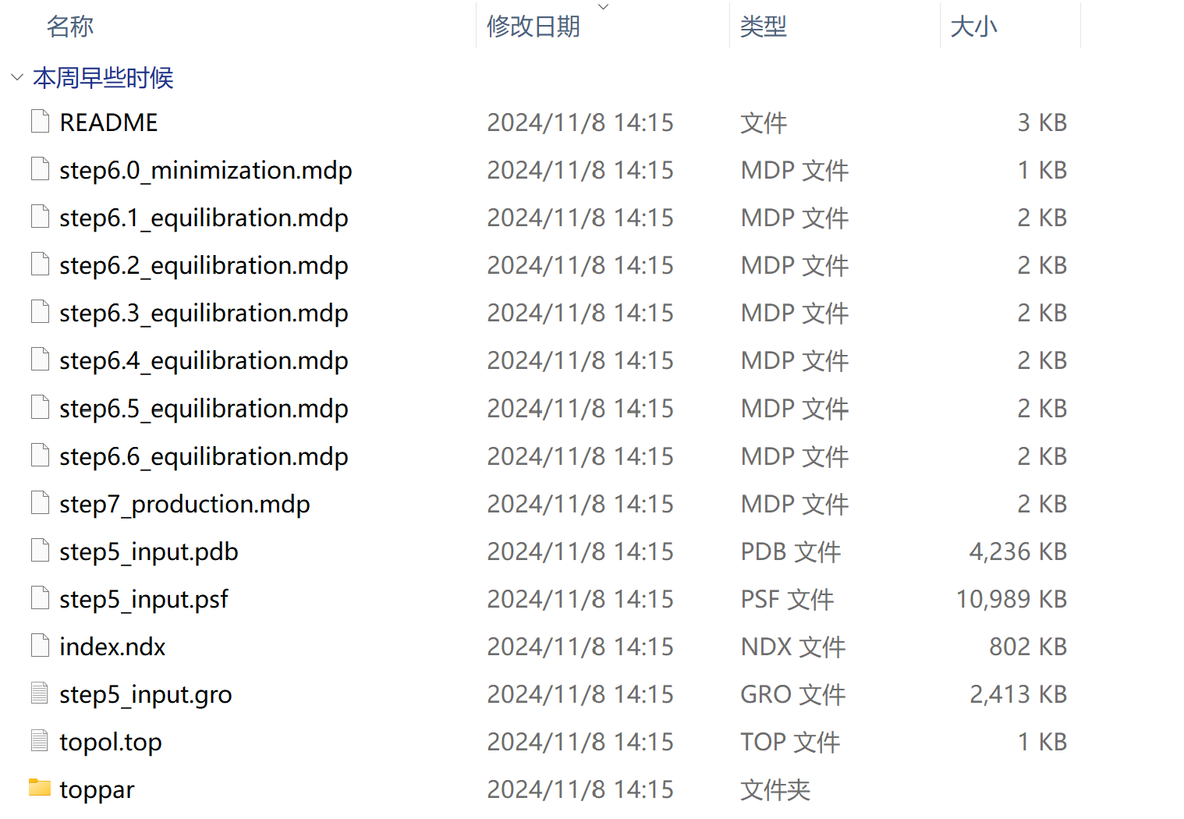

**(explain the uses of files)**

⚠️ **Do not change the file name above, or the commands on the script will not find the file !!!**

Then you can put your script into this folder

如果你没有脚本，请按照这个教程编写：（）

如果你已经有了脚本，就直接把脚本放入gromacs这个文件夹里面





（Special thanks to the script contributor-Kevin, 恩师乃真神人也)

你提交脚本应该包含这些东西：

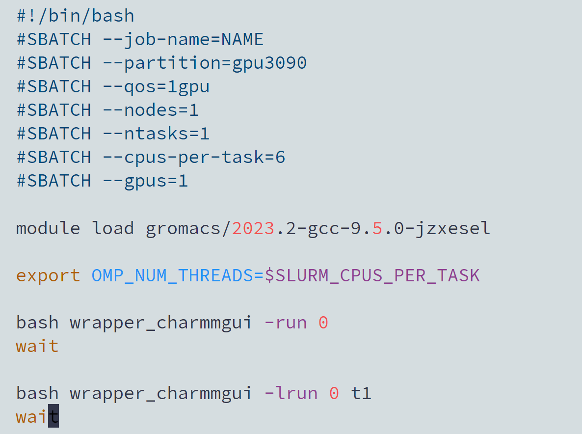

（explain your script）

Then you can upload your file to HPC, for a detailed tutorial on uploading files on HPC, please refer here: [https://hpc.xjtlu.edu.cn/login/#file-transfer](https://hpc.xjtlu.edu.cn/login/%23file-transfer)(建议用学校电脑开，自己的电脑就算连了学校网也开不了。。。)

**2.HPC （Use Temius as SSH client）**

1. Login HPC: ssh username@login.hpc.xjtlu.edu.cn

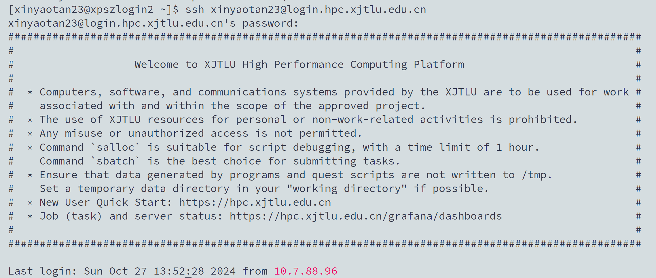

1. cd to “gromacs”



1. Check whether your command is runnable



⚠️**注意你加载的gromacs是脚本能够运行的版本！如果你加载了别的版本的gromacs会造成Open mpi的配置与HPC中的slurm不兼容**

**错误的例子：如果只运行了“module load gromacs”，这个命令会加载系统默认的gromacs版本：gromacs/2023.2-gcc-9.5.0-4fqejx4**

**然后系统会出现以下报错：**

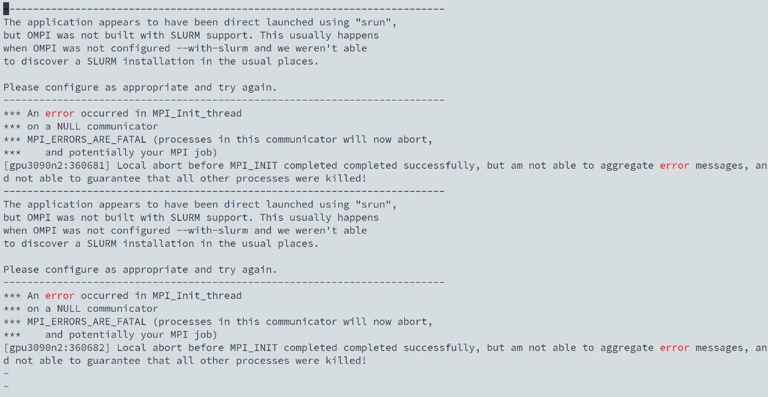

**这显示您的脚本与此gromacs版本不兼容**

**您可以使用“module avail”指令来检查您加载的gromacs版本:)**

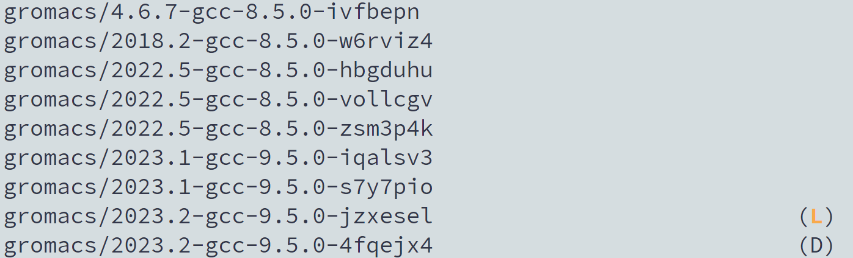

**L: Module is loaded D: Default Module**

**If it is runnable (no errors report), you can continue your following steps.**

1. **Submit**

Use “Sbatch” to submit your job to 计算节点

[Sbatch yourfilename]

注意你提交的脚本应该是含有

Then you will receive a job id

1. 查看作业状态

[tail -F slurm-yourjobid.out]来查看作业最新进程

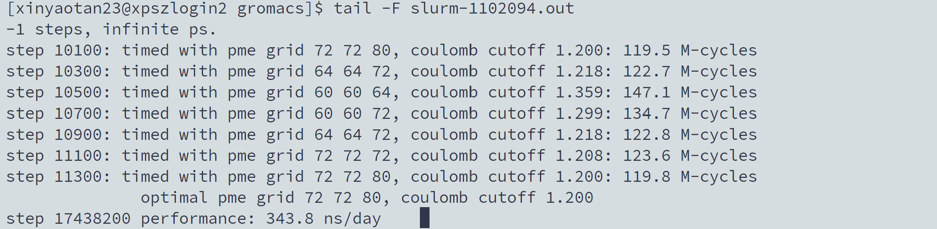

[squeue -u username]来查看作业运行状态



1. Stop your job

Use [scancel yourjobid]

**可能会出现的error：**

1. 未加载gromacs

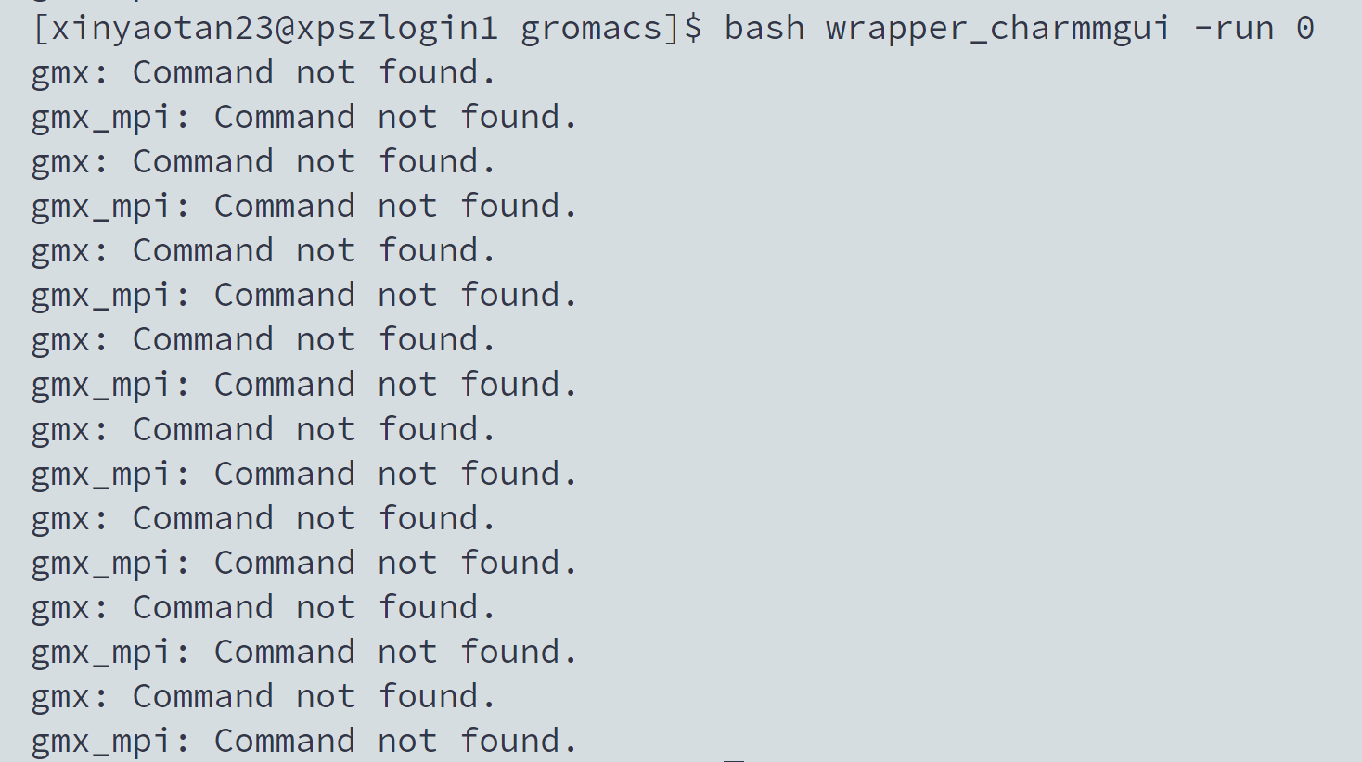

这是因为你没有执行[module load gromacs/2023.2-gcc-9.5.0-jzxesel]命令

(2) gmx command not found

这是因为你的脚本需要一些改动来适配在HPC上运行的gromacs

Use [vi yourscriptname] to view your script (text file)



You can use Tab to complete your code

Then you will view your file in HPC, here is the example:

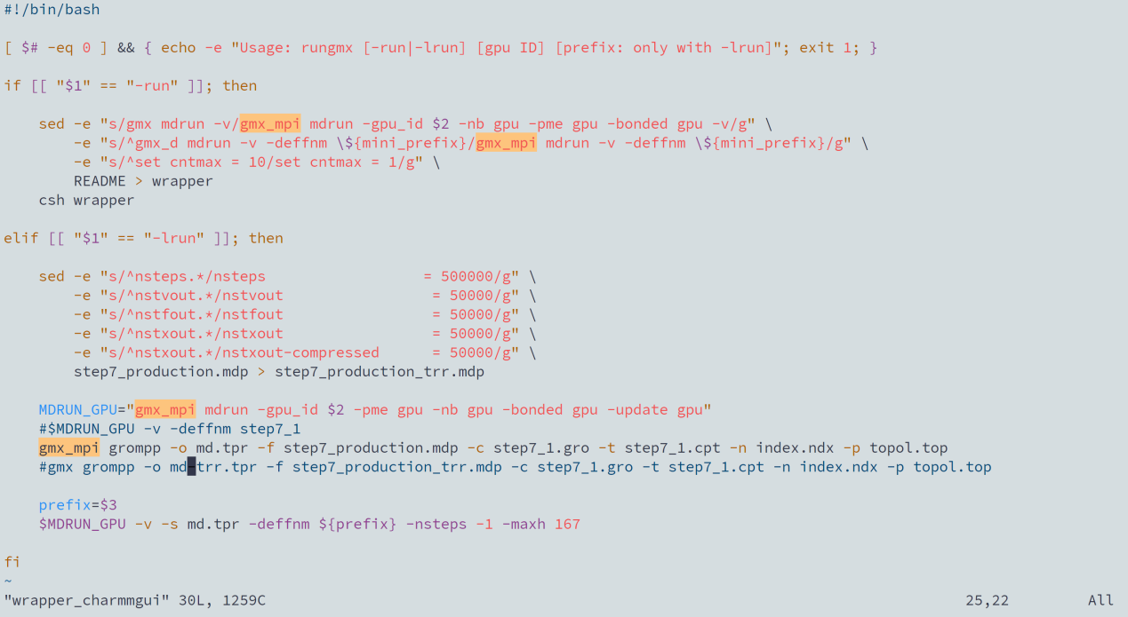

Press “i” to edit your script, “i” means “insert”.

Press “Esc” to exit insert mode.

Type [:wq] to return to shell.

编辑过的指令会高亮显示

同样，我们也需要更改一下README里的内容。

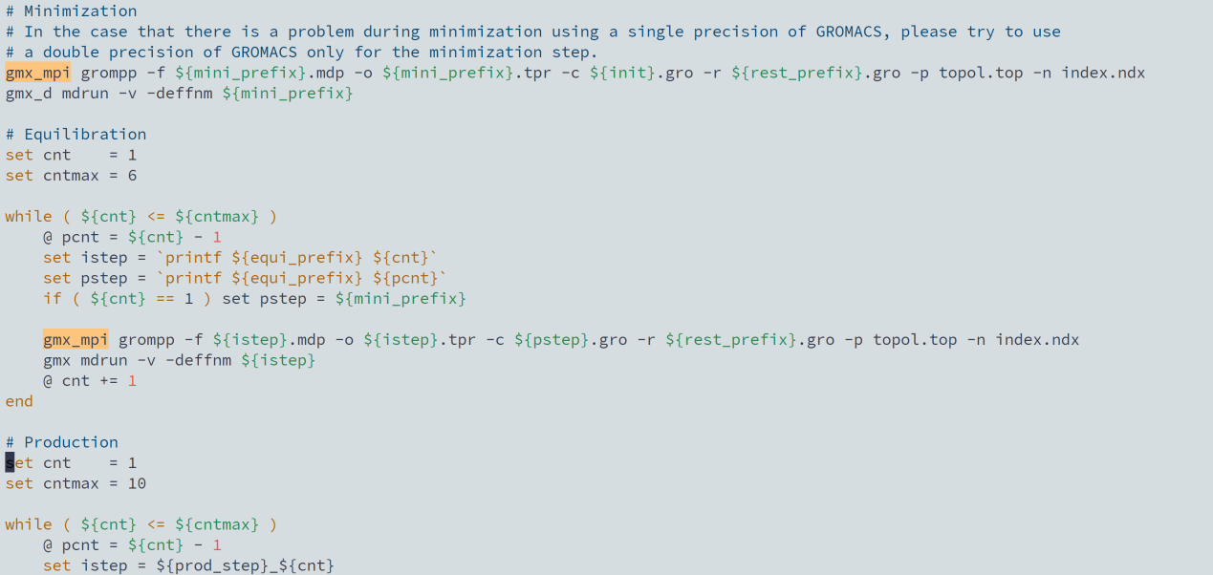

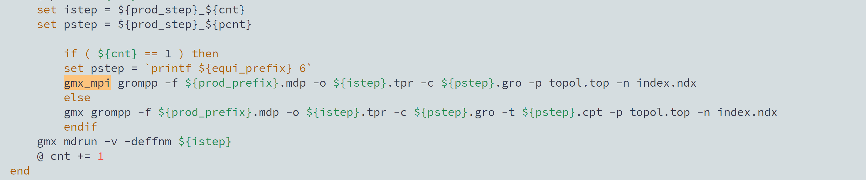

随后sbatch你的脚本，等待结果吧！

对于更加详细的HPC教程，请看：<https://hpc.xjtlu.edu.cn>